**1.WEB PAGE INCLUDING MAP AND FIXING HOTSPOT**

**Index.html:**

<!DOCTYPE html>

<html>

<head>

<title>Interactive Map of India</title>

</head>

<body>

<h1>Interactive Map of India</h1>

<p>Click on the marked cities to learn more.</p>

<map name="india-map">

<!-- Adjusted coordinates for Delhi (you may need to fine-tune) -->

<area href="file:///D:/Studies/VS%20code/Lab%20Exercises/1)%20Map/Dehli.html" shape="circle" coords="320,180,20" alt="Delhi">

<!-- Adjusted coordinates for Chennai (you may need to fine-tune) -->

<area href="file:///D:/Studies/VS%20code/Lab%20Exercises/1)%20Map/Chennai.html" shape="circle" coords="400,500,20" alt="Chennai">

</map>

<img src="image.jpg" usemap="#india-map" width="800" height="600" alt="Map of India">

</body>

</html>

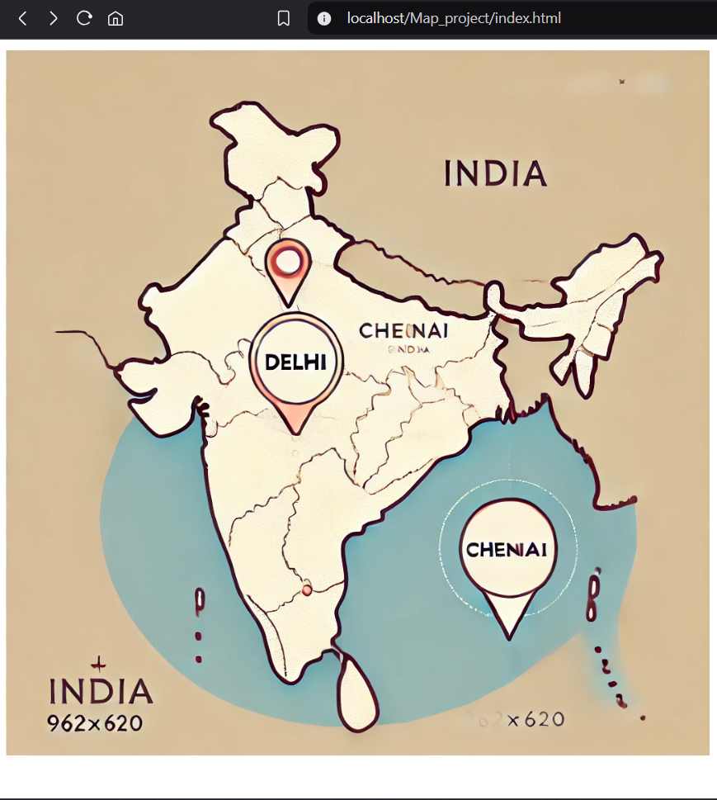

**Chennai.html:**

<html>

<head>

<title>CHENNAI</title>

</head>

<body bgcolor="lavender">

<p align="center">

<font face="arial" color="magenta" size="4">

<b><i><u><marquee>Welcome to CHENNAI</marquee></u></i></b>

</font>

</p>

<p align="left">

<font face="times new roman" color="red" size="4">

<b><u><i>About CHENNAI:</b></u></i>

</font>

Chennai is the capital of Tamil Nadu. It is a metropolitan city and ranks 4th best city in India. It has an international airport and Marina Beach.

</p>

<p align="left">

<font face="times new roman" color="red" size="4">

<b><u><i>Important places:</b></u></i>

</font>

<font face="times new roman" color="blue" size="3">

1. Marina Beach<br>2. Satyam Theater<br>3. Express Avenue

</font>

</p>

</body>

</html>

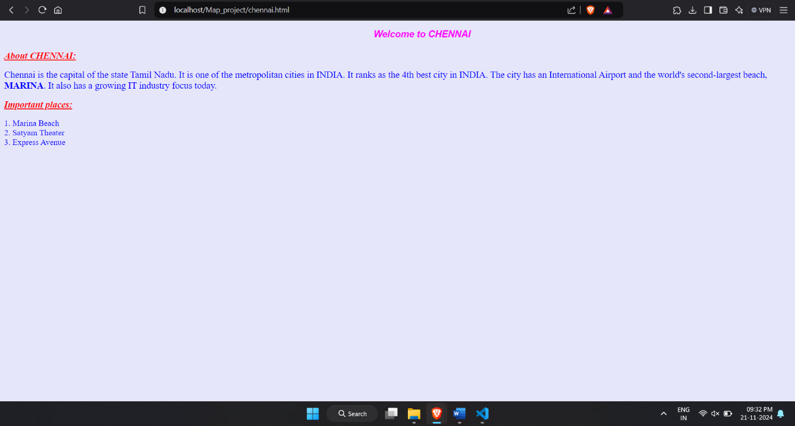

**Delhi.html:**

<html>

<head>

<title>DELHI</title>

</head>

<body bgcolor="lavender">

<p align="center">

<font face="arial" color="magenta" size="4">

<b><i><u><marquee>Welcome to DELHI</marquee></u></i></b>

</font>

</p>

<p align="left">

<font face="times new roman" color="red" size="4">

<b><u><i>About DELHI:</b></u></i>

</font>

Delhi is the capital of INDIA. It is one of the metropolitan cities in INDIA.

Indian politics is mainly concentrated in this city. The Supreme Court and defense headquarters are located here.

</p>

<p align="left">

<font face="times new roman" color="red" size="4">

<b><u><i>Important places:</b></u></i>

</font>

<font face="times new roman" color="blue" size="3">

1. India Gate<br>2. Taj Mahal<br>3. Ancient Buildings

</font>

</p>

</body>

</html>

